FACE BASED ATTENDANCE SYSTEM

RIO GLEN LOBO,KAUSTUBH PANDEY

**Abstract**

Facial Recognition is a technology of biometrics has been used in many areas like security

systems, human machine interaction and image processing techniques.The conventional method in the institutions are the faculty passes an attendance sheet or make roll calls to mark attendance of the student, which sometimes disturbs discipline of the class and the sheet further goes to the admin department,which is then updated to an excel sheet. This process is quite hectic and time consuming. The proposed solution for the current problem is through automation of attendance system using face recognition. This project describes the method of detection and

recognition the face in real time. Here, the camera is fixed in the classroom will capture the image. The faces in the

images are detected and then recognized with the database after which the attendance is marked.

The system used to calculate attendance automatically by recognizing the facial dimensions of all faces in an image and then

marks attendance.The system maintains a track of student attendance and makes predictions on fututre attendance trends

***Keywords:*** *Face Detection, LBPH, Image Capture, Extraction, Pre-processing,Face Recognition,Prediction*

# **INTRODUCTION[1]**

M

aintaining attendance is very important in all the educational institutions. But it’s the most difficult task in various institutions.

Every institution has its own method of attendance marking system. Some institutions use the attendance sheet, RFID reader,keystroke or biometric fingerprint techniques. The attendance sheet method has difficulty to maintaining and it has some manual errors.

Computers can detect a person's face using a digital image or video. It may be done by comparing the image captured in the real time with the database image. The facial characters obtained from a real time image is to be

compared with the facial characters of the database image stored. The automated attendance management system gives a facility to the faculties to reduce the burden in taking attendance. This system takes the attendance automatically using face recognition. However, it may be difficult to estimate the attendance using each result of face recognition independently because of the high the face detection rate.Further more a student may now also be able to predict future attendance trends using Linear Regression.

Face recognition has potential applications in security control,office automation, prevention of fraud, automatic personalization of environments,

# A. **Related Works**

This section represents previous work done regarding attendance marking system. Attendance marking are necessary to conclude and authentication of students as well as employees of organization. Many researches have been done in this area to improve and replace the traditional system of attendance by face recognition technology. Face recognition-based attendance marking system provides several advantages over conventional method of taking attendance in class. A number of algorithms for face recognition have been proposed but most of these works deal with only single image of a face at a time. By continuously observing of face information, proposed approach can solve the problem of the face detection and improve the accuracy of face recognition.This system aims to detect the position of each student and capture an image and then analyse the given image of class and mark attendance of all faces present in that image

## **B. Proposed Methodology**

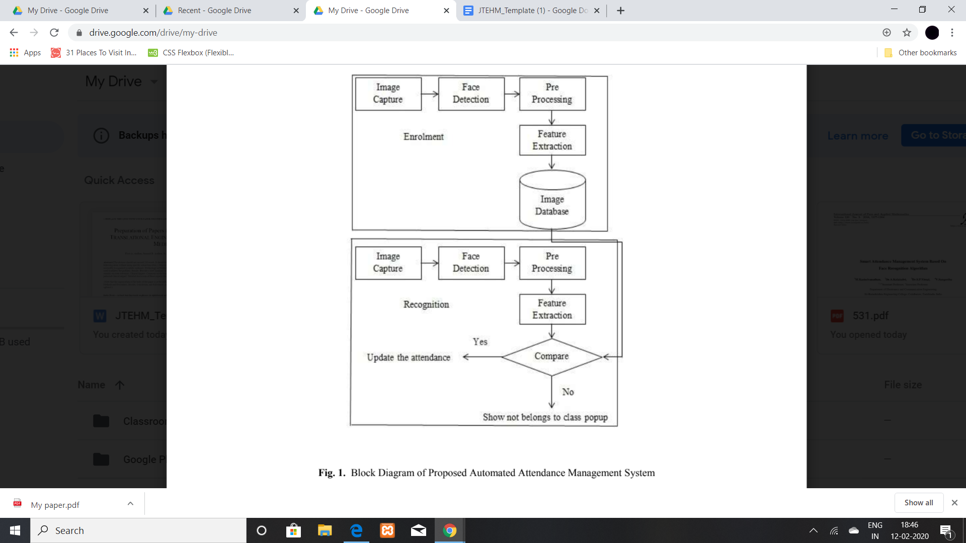

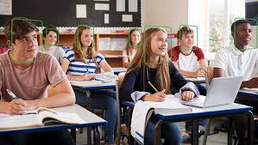

Figure 1 describes the working principle of the proposed methodology for automatic attendance marking system.

***C. Face Detection***

We make use of a Haar Cascade is basically a classifier which is used to detect particular objects from the source.

The haarcascade_frontalface_default.xml is a haar cascade designed by OpenCV to detect the frontal face. A Haar Cascade works by training the cascade on thousands of negative images with the positive image superimposed on it. The haar cascade is capable of detecting features from the source.

***D. Face recognition***

*With the facial images already extracted, cropped, resized and usually converted to grayscale, the face recognition algorithm is responsible for finding characteristics which best describe the image*

*To perform this task we use a LBPH(local binary patter histogram) recognizer.*

***Parameters: the LBPH uses 4 parameters****:*

***Radius****: the radius is used to build the circular local binary pattern and represents the radius around the central pixel. It is usually set to 1.*

***Neighbors****: the number of sample points to build the circular local binary pattern. Keep in mind: the more sample points you include, the higher the computational cost. It is usually set to 8.*

***Grid X****: the number of cells in the horizontal direction. The more cells, the finer the grid, the higher the dimensionality of the resulting feature vector. It is usually set to 8.*

***Grid Y****: the number of cells in the vertical direction. The more cells, the finer the grid, the higher the dimensionality of the resulting feature vector. It is usually set to 8.*

*Don’t worry about the parameters right now, you will understand them after reading the next steps.*

***2. Training the Algorithm****: First, we need to train the algorithm. To do so, we need to use a dataset with the facial images of the people we want to recognize. We need to also set an ID (it may be a number or the name of the person) for each image, so the algorithm will use this information to recognize an input image and give you an output. Images of the same person must have the same ID. With the training set already constructed, let’s see the LBPH computational steps.*

***3. Applying the LBP operation****: The first computational step of the LBPH is to create an intermediate image that describes the original image in a better way, by highlighting the facial characteristics. To do so, the algorithm uses a concept of a sliding window, based on the parameters radius and neighbors.*

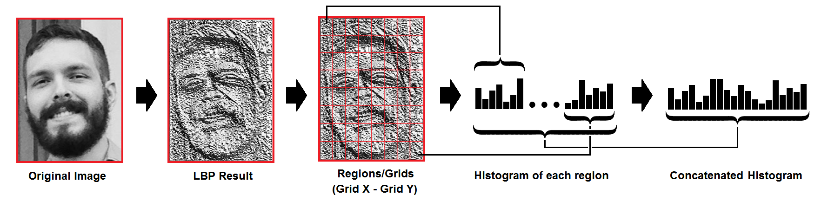

The above figure shows the working of LBPH recognizer

## **E.PREDICTING ATTENDANCE**

Here we make use of a Linear regressor to predict a given students future attendance trends

Linear Regression can be considered a Machine Learning algorithm that allows us to map numeric inputs to numeric outputs, fitting a line into the data points.

In other words, Linear Regression is a way of modelling the relationship between one or more variables. From the Machine Learning perspective, this is done to ensure generalization — giving the model the ability to predict outputs for inputs it has never seen before.

# *Training The Linear Regressors :*

Univariate Linear Regression, because we are trying to map one independent variable (x-value) to one dependent variable (y-value).



The above diagram is a sample attendance sheet

hence we provide student name or ID as X value and his attendance percentage as Y value

These X,Y are used to train the LINEAR REGRESSOR

using this trained recognizer we can predict the students future attendance trends

In case of bad Linear Regression model performance, we usually go for a higher polynomial function. This is basically the introduction of new variables into the Regressor function so that we allow more flexibility to it. However, this will cause the LR line not to be a straight line anymore.

## **F.Post-Processing:**

The post-processing mechanism involves the process of updating the names of the student into an excel sheet. The excel sheet can be maintained on a weekly basis or monthly basis to record the students' attendance. This attendance record can be sent to parents or guardians of students to report the performance of the student.

## **G.Problems of face detection and recognition**

1. Several 2D methods do well in performing recognition tasks only under moderate illumination variations within a given range, while performances noticeably degrade at large variations in illumination conditions.

2. Occlusions can dramatically affect face recognition performances, in particular if they are located on the upper-side of the face.

3. Pose changes such as head rotation also affect the identification process, because they introduce projective deformations and self-occlusion. This problem is accentuated where security cameras change the viewing angles when they are outside of the range of the designed viewing angle of a system.

4. Sometimes, even under an acceptable viewing angle, extreme expression changes of the face may result in false recognition.

5. Another important factor is related to the change of face over a period of time, as the shape of face changes in a nonlinear way due to ageing.

## 

## **G. Conclusion:**

CONCLUSION: Thus, the aim of this paper is to capture the video of the students, convert it into frames, relate it with the database to ensure their presence or absence, mark attendance to the particular student to maintain the record. The Automated Classroom Attendance System helps in increasing the accuracy and speed ultimately achieve the high-precision real-time attendance to meet the need for automatic classroom evaluation.

## 

## **H. Future development:**

. *FUTURE ENHANCEMENTS:*

* Automated Attendance System can be implemented in larger areas like in a seminar hall where it helps in sensing the presence of many people.
* Sometimes the poor lighting condition of the classroom may affect image quality which indirectly degrades system performance, this can be overcome in the latter stage by improving the quality of the video or by using some algorithms

## Social developments:

This project highlights the interconnectivity of various different real world and technical aspects.The combining of Computer Vision with the daily tedious task of marking attendance.

Such systems can later be used by various Educational and other such Organizations to implement

* Face Id based authorization
* Smart entry gates
* Anti bullying systems
* Expression based social analysis

Thereby ensuring safety in such organizations

*Software Developments:*  
Facial detection and recognition may further be improved by making use of higher quality Facial recognizers such as:

* Deep Vision AI.
* SenseTime.
* Amazon Rekognition.
* FaceFirst.
* Trueface.
* Kairos.
* Cognitec.
* face++

These higher quality systems may be linked to various other devices via IOT and can be used to send messages regarding the attendance.

**REFERENCES:**

1. N.Sudhakar Reddy, M.V.Sumanth, S.Suresh Babu, "A Counterpart Approach to Attendance and Feedback System using Machine Learning Techniques",Journal of Emerging Technologies and Innovative Research (JETIR), Volume 5, Issue 12, Dec 2018.
2. Samuel Lukas, Aditya Rama Mitra, Ririn Ikana Desanti, Dion Krisnadi, "Student Attendance System in Classroom Using Face Recognition Technique", Conference Paper DOI: 10.1109/ICTC.2016.7763360, Oct 2016.
3. International Journal of Engineering and Advanced Technology ‘Face Recognition Based Attendance System Nandhini R, Duraimurugan N, S.P.Chokkalingam’ISSN: 2249 – 8958, Volume-8, Issue-3S, February 2019
4. International Journal of Pure and Applied Mathematics Volume 120 No. 5 2018, 1377-1384 ’ Smart Attendance Management System Based On Face Recognition Algorithm M.Kasiselvanathan,Dr.A.Kalaiselvi,Dr.S.P.Vimal,V.Sangeetha
5. Nirmalaya Kar, Mrinal Kanti Debbarma, Ashim Saha, Dwijen RudraPal,” Study of implementing Automated Attendance System using ImplementingAutomated Attendance System Using face recognition Technique”, International Journal of Computer and Communication Engineering, Vol 1, No 2,July

2012

1. Shireesha Chintalapati, M.V. Raghunadh, “Automated Attendance Management System Based on Face Recognition Algorithms,” IEEE,2013.

’

1. rio1glen@gmail.com,kaushtuhb.11@gmail.com